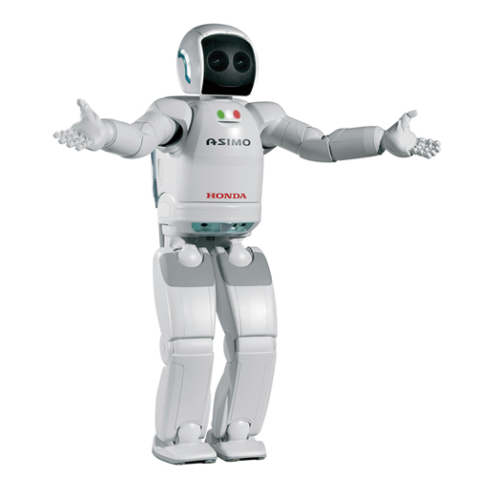 | Read this article on “Honda's ASIMO robot” and fill in the following gaps.

How ASIMO works

Robots already do a lot of the jobs that we humans don't want to do, can't do, or simply can't do as well as our robotic counterparts(contrapartidas/clones roboticos). In factories around the world, disembodied robot arms assemble cars, delicately place candies (sweet es caramelo en UK) into their boxes, and do all sorts of tedious jobs. There are even a handful (handful: puñado) of robots on the market whose sole job is to vacuum the floor. Honda engineers have been busy creating the ASIMO robot for more than 17 years. In this article, we'll find out what makes ASIMO the most advanced humanoid robot to date.
What is ASIMO?
ASIMO, which stands for Advanced Step in Innovative Mobility, was developed (1) by the Honda Motor Company and is the (2) most advanced humanoid robot in the world. According (3) to the ASIMO Web site, ASIMO is the only humanoid robot in the world that can walk independently and climb stairs. While there are several (4) other humanoid robots that can walk, none have the smooth, realistic gait (aspecto) that ASIMO has.
In addition (5) to ASIMO's ability to walk like we do, it can (6) also understand some spoken commands and recognize faces. ASIMO has arms and hands so it can do things (7) like turn on light switches, open doors, carry objects, and push carts.
Honda's vision for ASIMO
Rather (8) than building a robot that would be another toy, Honda wanted to create a robot that would be a helper for people -- a robot to help (9) around the house, help the elderly, or help someone confined to a wheelchair or bed. ASIMO is 4 feet (1.2 meters) (10) tall/high ,which is just the right height to look eye to eye with someone seated in a chair. This allows ASIMO (11) to do the jobs it was created to do without being too big and menacing. Often referred to (12) as looking like a "kid wearing a spacesuit," ASIMO's friendly appearance and nonthreatening size work well for the purposes Honda had in mind when creating (13) it.
ASIMO could also (14) do jobs that are too dangerous for humans to do, like going (15) to/into hazardous areas, disarming bombs, or fighting fires.
-El numero 12, la expresion referred to, va seguida de as. Referred to as.

